

SAL COLLEGE OF ENGINEERING

POSTER PRESENTATION 2025

ER MODELS FOR

Abstract
Objectives
To organize TCS data efficiently and reduce redundancy.
To track employees, projects, and clients accurately.
To reduce redundancy and maintain data accuracy.

The ER model of TCS represents the organization’s data structure, including Company, Department, Employee, Project, and Client. It defines how these entities are related to manage employees, projects, and clients efficiently, ensuring organized and accurate information flow.

Workflow / Process / Flow Chart
Introduction

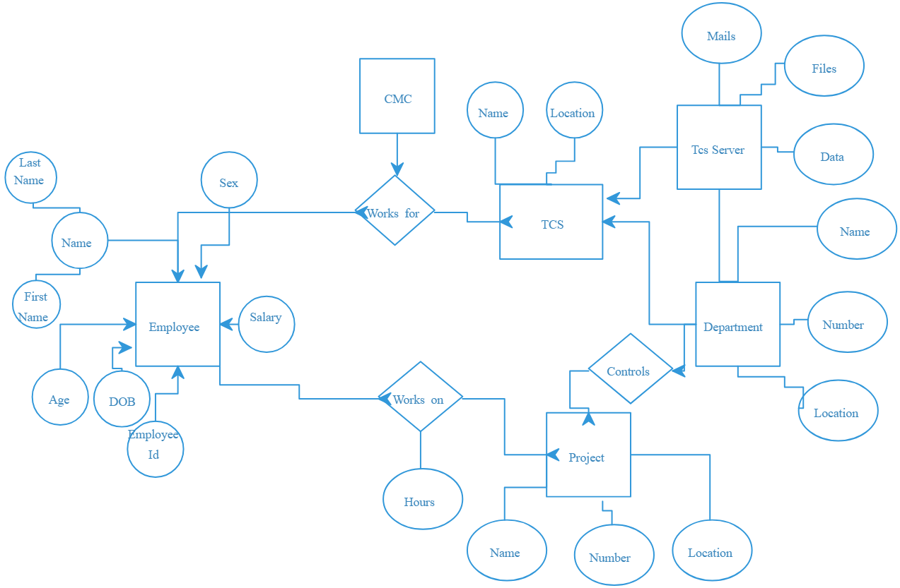
The TCS ER model represents the relationships between Company, Department, Employee, Project, and Client. It helps organize data efficiently and ensures accurate information management.

Technology / Methods/ Algorithm

Use DBMS and ER modeling tools to organize company data.
Identify entities, their attributes, and relationships.
Determine keys and cardinality, then create the ER diagram.

Results / Outcome
Prototype

Provides a clear structure of TCS data, including Company, Department, Employee, Project, and Client.
Helps in efficient data management, reducing redundancy and errors.
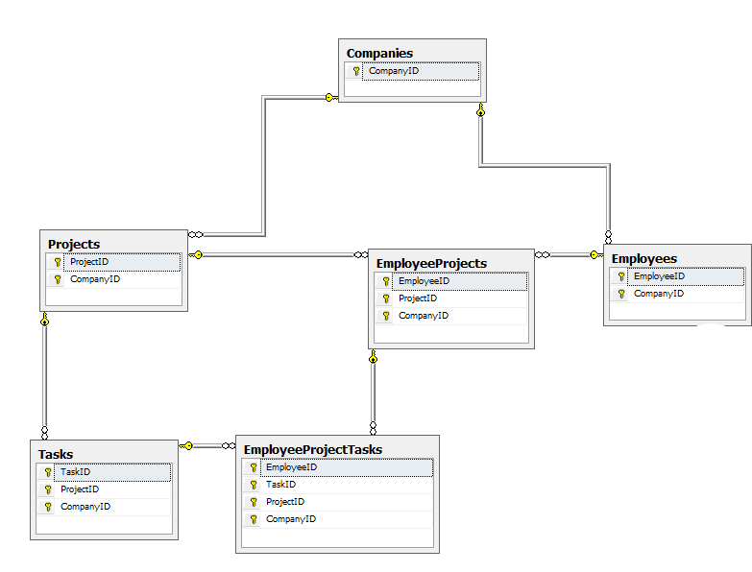

Conclusion
The TCS ER model organizes company data efficiently, reduces redundancy, and ensures accurate information. It supports better resource management, project tracking, and decision-making.

References

Future Scope
The TCS ER model can be expanded to include Payroll, Attendance, and Performance.
- https://www.geeksforgeeks.org/entity-relationship-model-in-dbms/
- https://www.tutorialspoint.com/dbms/dbms_er_model.htm
Presented By: - CHANPURA KEYUR D. (251133107004),MAHERIYA HARDIK S. (251133107016),
Guided By: - Prof. ROSHNI V PATEL

